SOFTWARE ENGINERRING

ASSIGNMENT 2

ENVIROMENT SETUP

Windows 10

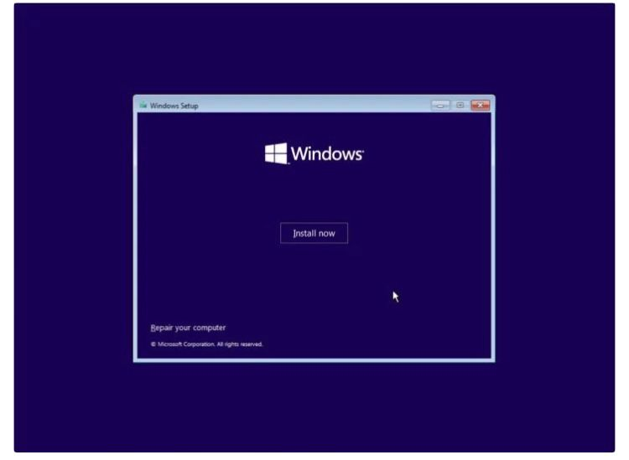

Click install now

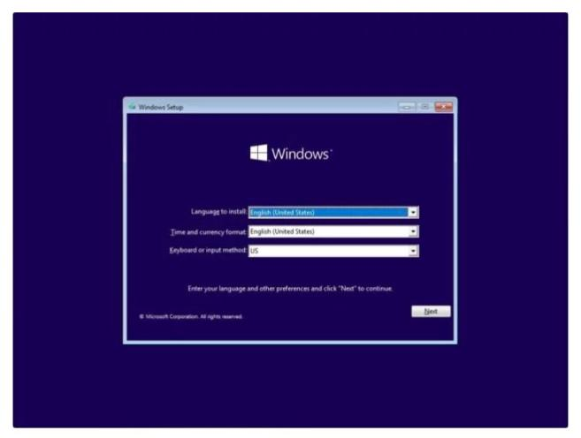

Selected the english language

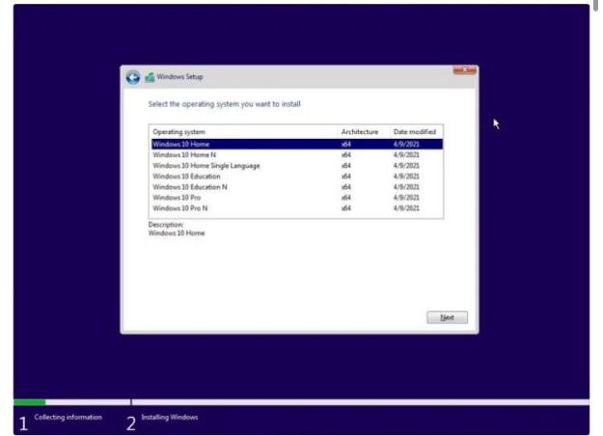

Select the operating system l selected windows home

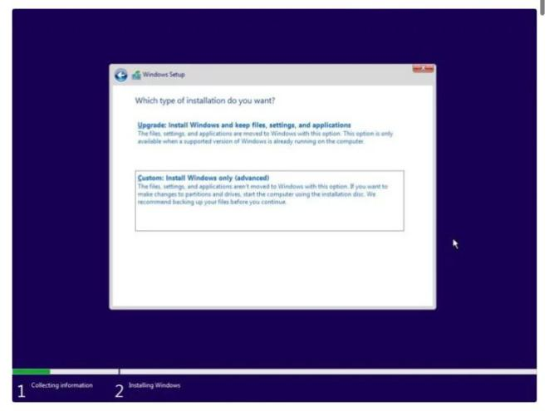

Custom install

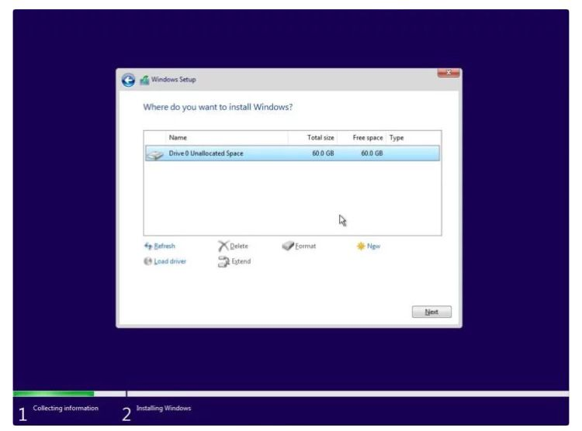

Selected the partition struggle to change from an (MBR) to GPT since it was a USB installation but solved the problem in command prompt by converting the disk to GPT.

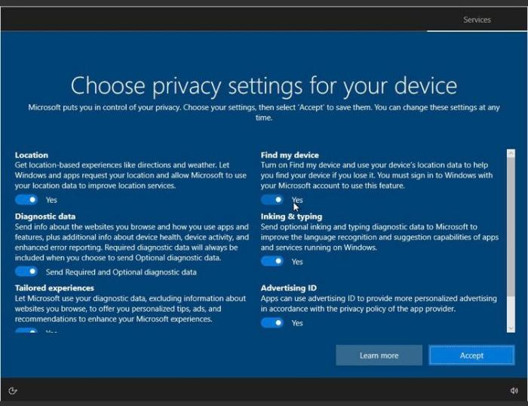

Accepted all.

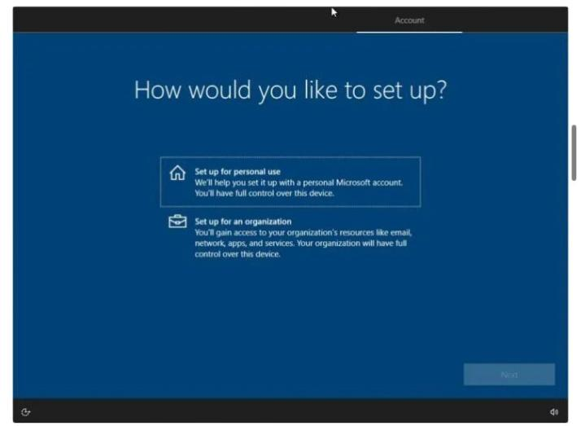

Set up personal account

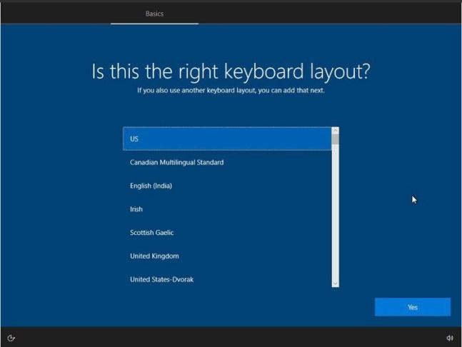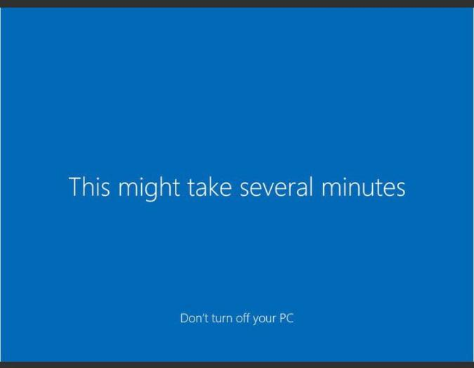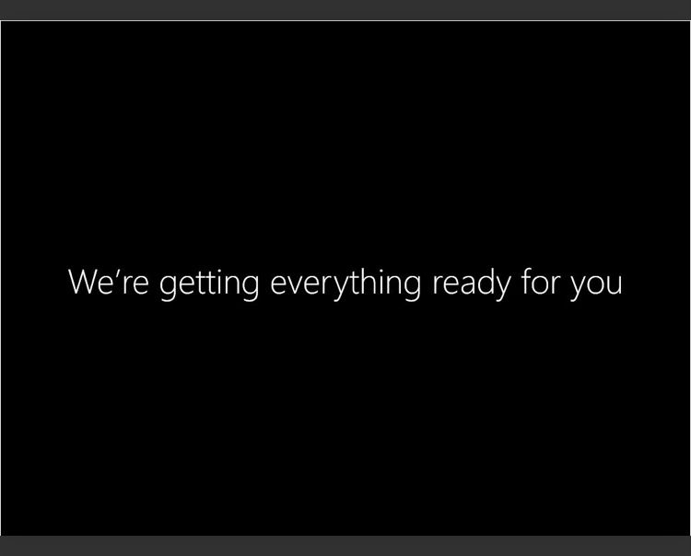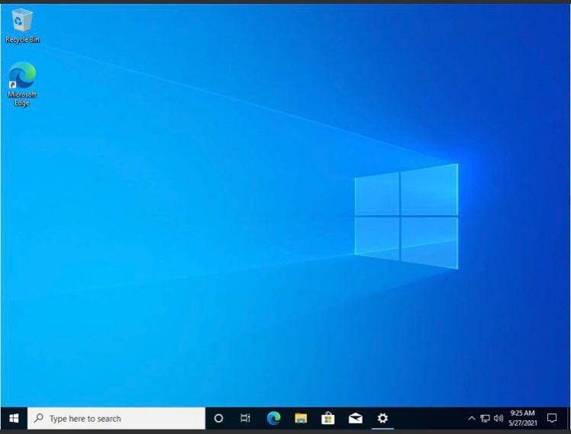

NOW LOGGED INTO WINDOWS 10

IDE INSTALLATION

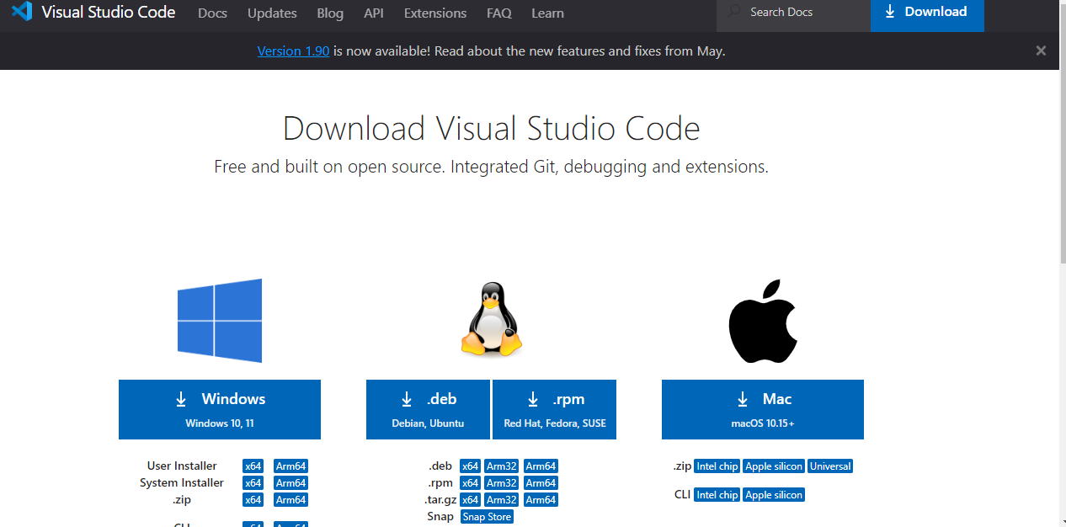

DOWNLOADED THE LATEST VERSION ON VISUAL STUDIO CODE

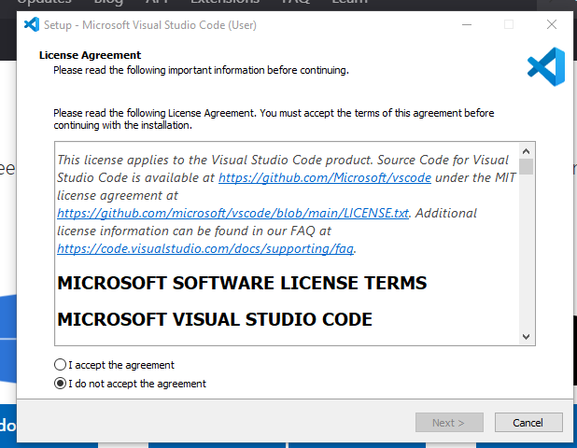

CLICK ON AGREE TO TERMS AND CONDITIONS

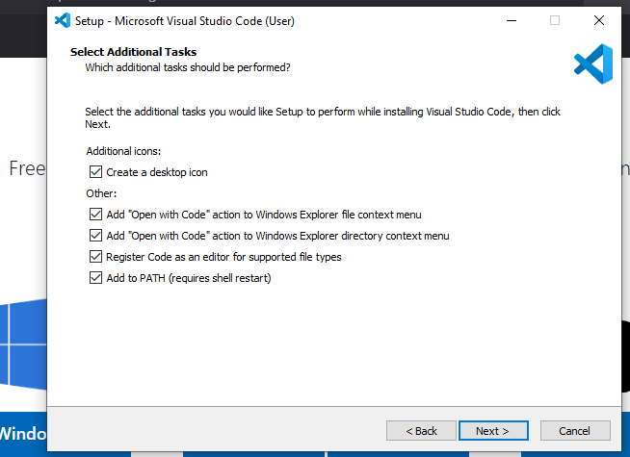

SELECT ALL THE THE ADDITONAL OPTIONS

AND CLICK NEXT

INSTALLATION IS FINISHED AND VISUAL STUDIO IS ION THE MACHINE.

DOWNLODED AND INSTALLED LIVE SERVER EXTENSION

PYTHON INSTALLATION

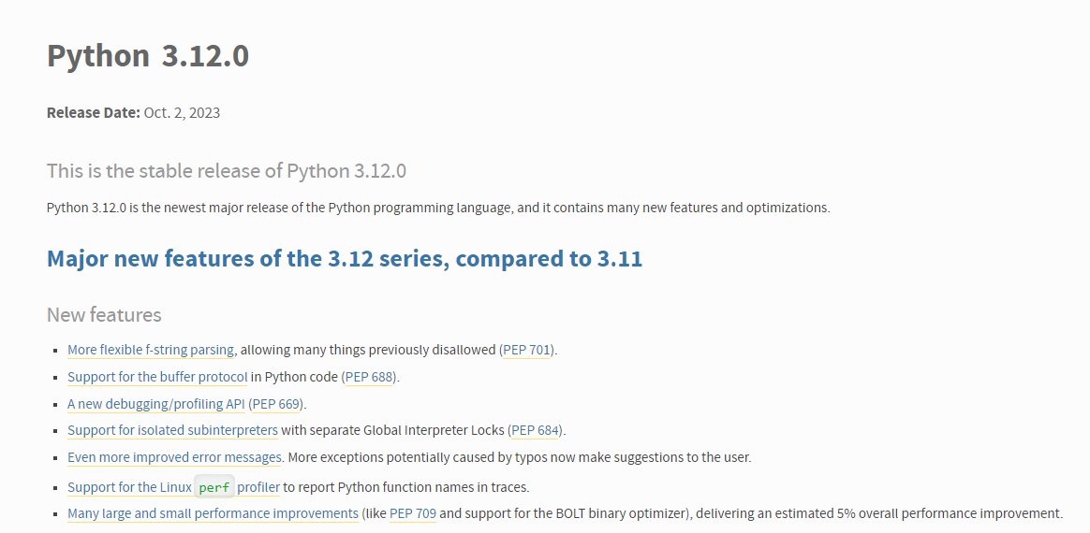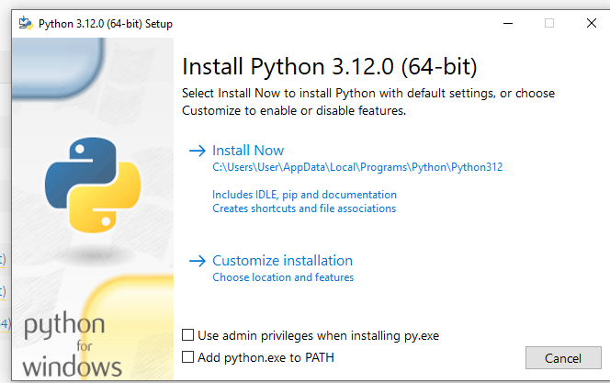

DOWNLOAD THE STABLE VERSION OF PYTHON

CLICK ON ADD PYTHON PATH AND THEN INSTALL NOW

PYTHON INSTALLS AND YOU CAN CHECK VERSION THROUGH GIT BASH

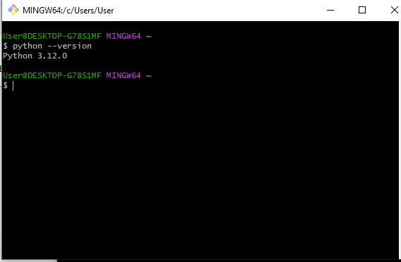

MySQL INSTALLATION

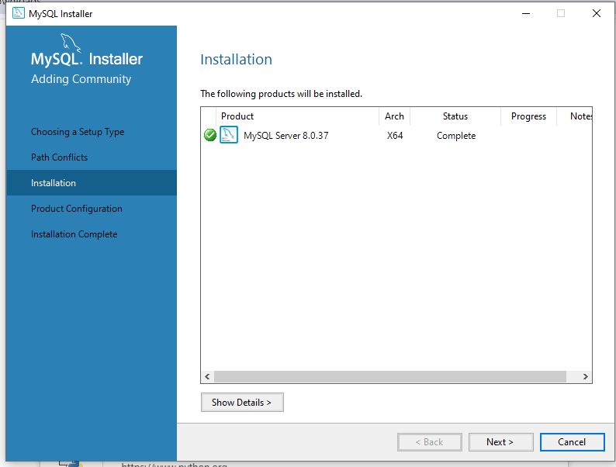

INSTALLED MY SQL SERVER AND CONFIGURED IT BY CREATING A PASSWORD

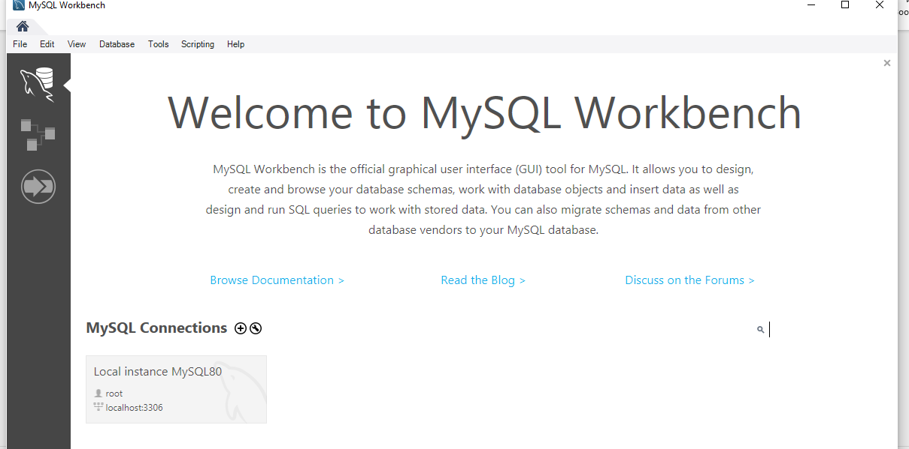

INSTALLED MY SQL WORKBENCH TO AS A PLATFORM TO WRITE AND RUN SQL QUERIES.

PLUGGINS INSTALLATION

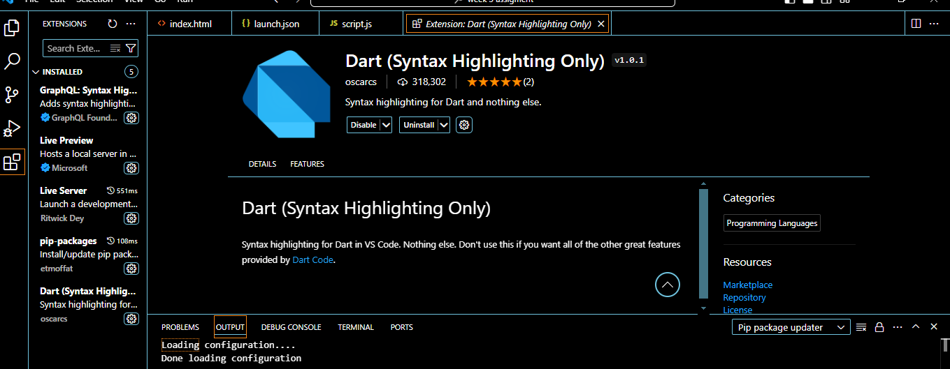

INSTALLED EXTENSIONS LIKE LIVE SERVER AND LIVE PREVIEW